Thursday 14th January 2021
Dear Parents / Carers

Draw with Rob

You may be aware of drawing tutorials called ‘Draw with Rob’ or you may have some of his books at home.

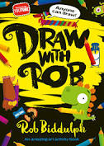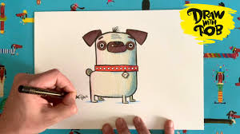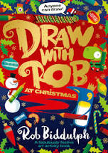

Rob Biddulph is an author and artist and during the lockdown earlier in the year, he created draw-along videos for children (and adults) to follow to draw lots of different animals and creatures. We thought you would enjoy the opportunity to develop your drawing skills by following some of the tutorials.

The videos are available to follow at:

http://www.robbiddulph.com/draw-with-rob

We would love to see your drawings, please send to the email below or tweet us.

Happy sketching!

Kind regards

Nichola Allerston

Email me at nichola.allerston@marketrasen.lincs.sch.uk

Tweet your pictures @northwoldsfed

